《计算机图形学》
实验报告5

班 级 信计160

学 号 10162648

姓 名 何威阳

批阅教师 赵宏庆

实验5 综合画图

实验目的及要求
目的：OpenGL实现生成基本图形,并用下拉菜单形式分别把各种基本图形显示出来。
要求：1 实现 表3-6（P61-P62）中各项分别显示；
2 实现 图3-19（P65-P66）；
3 实现纹理映射字体。在屏幕上显示你的基本信息（学号+姓名）P71。

实验步骤
绘制一个菜单栏将所有的各项任务全都放到菜单栏之中。
- 首先定义一些变量以用来方便switch语句的编写
enum{Points,Lines,polygon,triangles,quads,linestrip,lineloop,trianglestrip,trianglefan,quadstrip,text,fly}; //定义变量
- 定义画出各种图形的函数；
void CMFCApplication5View::DrawPoints() //定义运用GL_POINTS的函数画一些点
{
glColor3f(1.0, 0.0, 0.0);
glPointSize(5.0f);
glBegin(GL_POINTS);
glVertex2f(0.0, 0.0);
glVertex2f(0.1, 0.1);
glVertex2f(-0.1, 0.2);
glVertex2f(-0.3, 0.3);
glEnd();

}

void CMFCApplication5View::DrawLines() //定义运用GL_LINES的函数画一系列线
{
glColor3f(1.0, 0.0, 0.0);
glBegin(GL_LINES);
glVertex2f(0.5f,0.5f);
glVertex2f(0.0f,-0.5f);
glVertex2f(0.6f,0.6f);
glVertex2f(0.1f,-0.4f);
glEnd();

}

void CMFCApplication5View::DrawPolygon() //定义运用GL_POLYGON的函数画一个区域
{ glColor3f(1.0, 0.0, 0.0);
glBegin(GL_POLYGON);
glVertex2f(0.1,0.0);
glVertex2f(0.0,0.5);
glVertex2f(0.25,0.7);
glVertex2f(0.5,0.5);
glVertex2f(0.4,0.0);

glEnd();

}

void CMFCApplication5View::DrawTriangles() //运用GL_TRIANGLES函数画三角形
{
glColor3f(1.0, 0.0, 0.0);
glBegin(GL_TRIANGLES);
glVertex2f(0.0,0.0);
glVertex2f(0.25,0.5);
glVertex2f(0.5,0.0);
//glVertex2f(0.5,0.0);
glEnd();
}

void CMFCApplication5View::DrawQuads() //运用GL_QUADS函数画一个四边形
{
glColor3f(1.0, 0.0, 0.0);
glBegin(GL_QUADS);
glVertex2f(0.0,0.0);
glVertex2f(0.0,0.5);
glVertex2f(0.5,0.5);
glVertex2f(0.5,0.0);
glEnd();
}

void CMFCApplication5View::DrawLinestrip() //运用GL_LINE_STRIP函数画一个线系
{
glColor3f(1.0, 0.0, 0.0);
glBegin(GL_LINE_STRIP);
glVertex2f(0.5f,0.5f);
glVertex2f(0.0f,-0.5f);
glVertex2f(0.4f,0.5f);
glVertex2f(0.0f,-0.3f);
glVertex2f(0.6f,0.6f);
glVertex2f(0.1f,-0.4f);
glEnd();
}

void CMFCApplication5View::DrawLineloop() //画一组首尾相连的线
{
glColor3f(1.0, 0.0, 0.0);
glBegin(GL_LINE_LOOP);
glVertex2f(0.5f,0.5f);
glVertex2f(0.0f,-0.5f);
glVertex2f(0.4f,0.5f);
glVertex2f(0.0f,-0.3f);
glEnd();

}

void CMFCApplication5View::DrawTrianglestrip() //运用GL_TRIANGLE_STRIP函数画一些系列三角形。
{
glColor3f(1.0, 0.0, 0.0);
glBegin(GL_TRIANGLE_STRIP);
glVertex2f(0.5f,0.5f);
glVertex2f(0.0f,-0.5f);
glVertex2f(0.4f,0.5f);
glVertex2f(0.0f,-0.3f);
glVertex2f(0.1f,0.5f);
glVertex2f(0.5f,-0.3f);

glEnd();

}

void CMFCApplication5View::DrawTrianglefan() //运用GL_TRIANGLE_FAN函数用三角形组成一个扇形
{
glColor3f(1.0, 0.0, 0.0);
glBegin(GL_TRIANGLE_FAN);
glVertex2f(0.0f,0.0f);
glVertex2f(0.0f,0.5f);
glVertex2f(0.15f,0.45f);
glVertex2f(0.25f,0.3f);
glVertex2f(0.35f,0.2f);
glVertex2f(0.45f,0.1f);

glEnd();

}

void CMFCApplication5View::DrawQuadstrip() //运用GL_QUAD_STRIP函数画一系列四边形
{
glColor3f(1.0, 0.0, 0.0);
glBegin(GL_QUAD_STRIP);
glVertex2f(0.5f,0.5f);
glVertex2f(0.0f,-0.5f);
glVertex2f(0.4f,0.5f);
glVertex2f(0.0f,-0.3f);
glVertex2f(0.1f,0.5f);
glVertex2f(0.5f,-0.3f);
glVertex2f(0.6f,0.8f);
glVertex2f(0.2f,-0.6f);

glEnd();

}

其中输出中文字体和点画模式的图形的较为复杂
这里给出详细的说明
首先是输出中文字体的方法：
因为中文无法直接输出，所以要先选择中文字体的函数
void CMFCApplication5View::selectFont(int size, int charset, const char *face)
{
HFONT hFont = CreateFontA(size, 0, 0, 0, FW_MEDIUM, 0, 0, 0,
charset, OUT_DEFAULT_PRECIS, CLIP_DEFAULT_PRECIS,
DEFAULT_QUALITY, DEFAULT_PITCH | FF_SWISS, face);
HFONT hOldFont = (HFONT)SelectObject(wglGetCurrentDC(), hFont);
DeleteObject(hOldFont);

}

void CMFCApplication5View::drawCNString(const char *str)//定义输出中文的函数
{
int len, i;
wchar_t* wstring;
HDC hDC = wglGetCurrentDC();
GLuint list = glGenLists(1);

// 计算字符的个数
// 如果是双字节字符的（比如中文字符），两个字节才算一个字符
// 否则一个字节算一个字符
len = 0;
for (i = 0; str[i] != '\0'; ++i)
{
if (IsDBCSLeadByte(str[i]))
++i;
++len;
}

// 将混合字符转化为宽字符
wstring = (wchar_t*)malloc((len + 1) * sizeof(wchar_t));
MultiByteToWideChar(CP_ACP, MB_PRECOMPOSED, str, -1, wstring, len);
wstring[len] = L'\0';

// 逐个输出字符
for (i = 0; i<len; i++) {
wglUseFontBitmapsW(hDC, wstring[i], 1, list);
glCallList(list);
}

// 回收所有临时资源
free(wstring);
glDeleteLists(list, 1);

}

void CMFCApplication5View::Text() //选择字体、颜色和位置输出文字
{
glColor3f(0.0f,0.0f,1.0f);
selectFont(48, GB2312_CHARSET, "楷体_GB2312");
glRasterPos2f(0,0);
drawCNString("10162648 何威阳");

}
然后是生成点画图形的方法：
定义画图的函数
void CMFCApplication5View::DrawFly()
{

GLubyte fly[] = {
0x00, 0x00, 0x00, 0x00, 0x00, 0x00, 0x00, 0x00,
0x03, 0x80, 0x01, 0xC0, 0x06, 0xC0, 0x03, 0x60,
0x04, 0x60, 0x06, 0x20, 0x04, 0x30, 0x0C, 0x20,
0x04, 0x18, 0x18, 0x20, 0x04, 0x0C, 0x30, 0x20,
0x04, 0x06, 0x60, 0x20, 0x44, 0x03, 0xC0, 0x22,
0x44, 0x01, 0x80, 0x22, 0x44, 0x01, 0x80, 0x22,
0x44, 0x01, 0x80, 0x22, 0x44, 0x01, 0x80, 0x22,
0x44, 0x01, 0x80, 0x22, 0x44, 0x01, 0x80, 0x22,
0x66, 0x01, 0x80, 0x66, 0x33, 0x01, 0x80, 0xCC,
0x19, 0x81, 0x81, 0x98, 0x0C, 0xC1, 0x83, 0x30,
0x07, 0xe1, 0x87, 0xe0, 0x03, 0x3f, 0xfc, 0xc0,
0x03, 0x31, 0x8c, 0xc0, 0x03, 0x33, 0xcc, 0xc0,
0x06, 0x64, 0x26, 0x60, 0x0c, 0xcc, 0x33, 0x30,
0x18, 0xcc, 0x33, 0x18, 0x10, 0xc4, 0x23, 0x08,
0x10, 0x63, 0xC6, 0x08, 0x10, 0x30, 0x0c, 0x08,
0x10, 0x18, 0x18, 0x08, 0x10, 0x00, 0x00, 0x08
};
GLubyte halftone[] = {
0xAA, 0xAA, 0xAA, 0xAA, 0x55, 0x55, 0x55, 0x55,
0xAA, 0xAA, 0xAA, 0xAA, 0x55, 0x55, 0x55, 0x55,
0xAA, 0xAA, 0xAA, 0xAA, 0x55, 0x55, 0x55, 0x55,
0xAA, 0xAA, 0xAA, 0xAA, 0x55, 0x55, 0x55, 0x55,
0xAA, 0xAA, 0xAA, 0xAA, 0x55, 0x55, 0x55, 0x55,
0xAA, 0xAA, 0xAA, 0xAA, 0x55, 0x55, 0x55, 0x55,
0xAA, 0xAA, 0xAA, 0xAA, 0x55, 0x55, 0x55, 0x55,
0xAA, 0xAA, 0xAA, 0xAA, 0x55, 0x55, 0x55, 0x55,
0xAA, 0xAA, 0xAA, 0xAA, 0x55, 0x55, 0x55, 0x55,
0xAA, 0xAA, 0xAA, 0xAA, 0x55, 0x55, 0x55, 0x55,
0xAA, 0xAA, 0xAA, 0xAA, 0x55, 0x55, 0x55, 0x55,
0xAA, 0xAA, 0xAA, 0xAA, 0x55, 0x55, 0x55, 0x55,
0xAA, 0xAA, 0xAA, 0xAA, 0x55, 0x55, 0x55, 0x55,
0xAA, 0xAA, 0xAA, 0xAA, 0x55, 0x55, 0x55, 0x55,
0xAA, 0xAA, 0xAA, 0xAA, 0x55, 0x55, 0x55, 0x55,
0xAA, 0xAA, 0xAA, 0xAA, 0x55, 0x55, 0x55, 0x55
};

glColor3f(0.0, 0.0, 0.0);
glRectf(0.0, 0.0, -0.2, 0.4);
glEnable(GL_POLYGON_STIPPLE);//开启开关
glPolygonStipple(fly);//应用掩膜
glRectf(0.0, 0.0, 0.2, 0.4);
glPolygonStipple(halftone);
glRectf(0.2, 0.0, 0.4, 0.4);
glDisable(GL_POLYGON_STIPPLE);//关闭开关
glFlush();

}
- 定义DrawScene（）函数将所有的函数放入函数中：
void CMFCApplication5View::DrawScene()
{
glClearColor(1.0f,1.0f,1.0f,1.0f);
glClear(GL_COLOR_BUFFER_BIT|GL_DEPTH_BUFFER_BIT);
glColor3f(1.0f,1.0f,0.0f);

switch(m_controlHwy)
{
case Points: DrawPoints();break;
case Lines: DrawLines();break;
case polygon: DrawPolygon();break;
case triangles: DrawTriangles();break;
case quads: DrawQuads();break;
case linestrip: DrawLinestrip();break;
case lineloop: DrawLineloop();break;
case trianglestrip: DrawTrianglestrip();break;
case trianglefan: DrawTrianglefan();break;
case quadstrip: DrawQuadstrip();break;
case text: Text();break;
case fly: DrawFly();break;
}
glFinish();

}
- 将DrawScene函数放入OnDraw函数中、
void CMFCApplication5View::OnDraw(CDC* pDC)
{
CMFCApplication5Doc* pDoc = GetDocument();
ASSERT_VALID(pDoc);
RenderScene(); //渲染场景
DrawScene();
- 将个函数链接到窗口上：
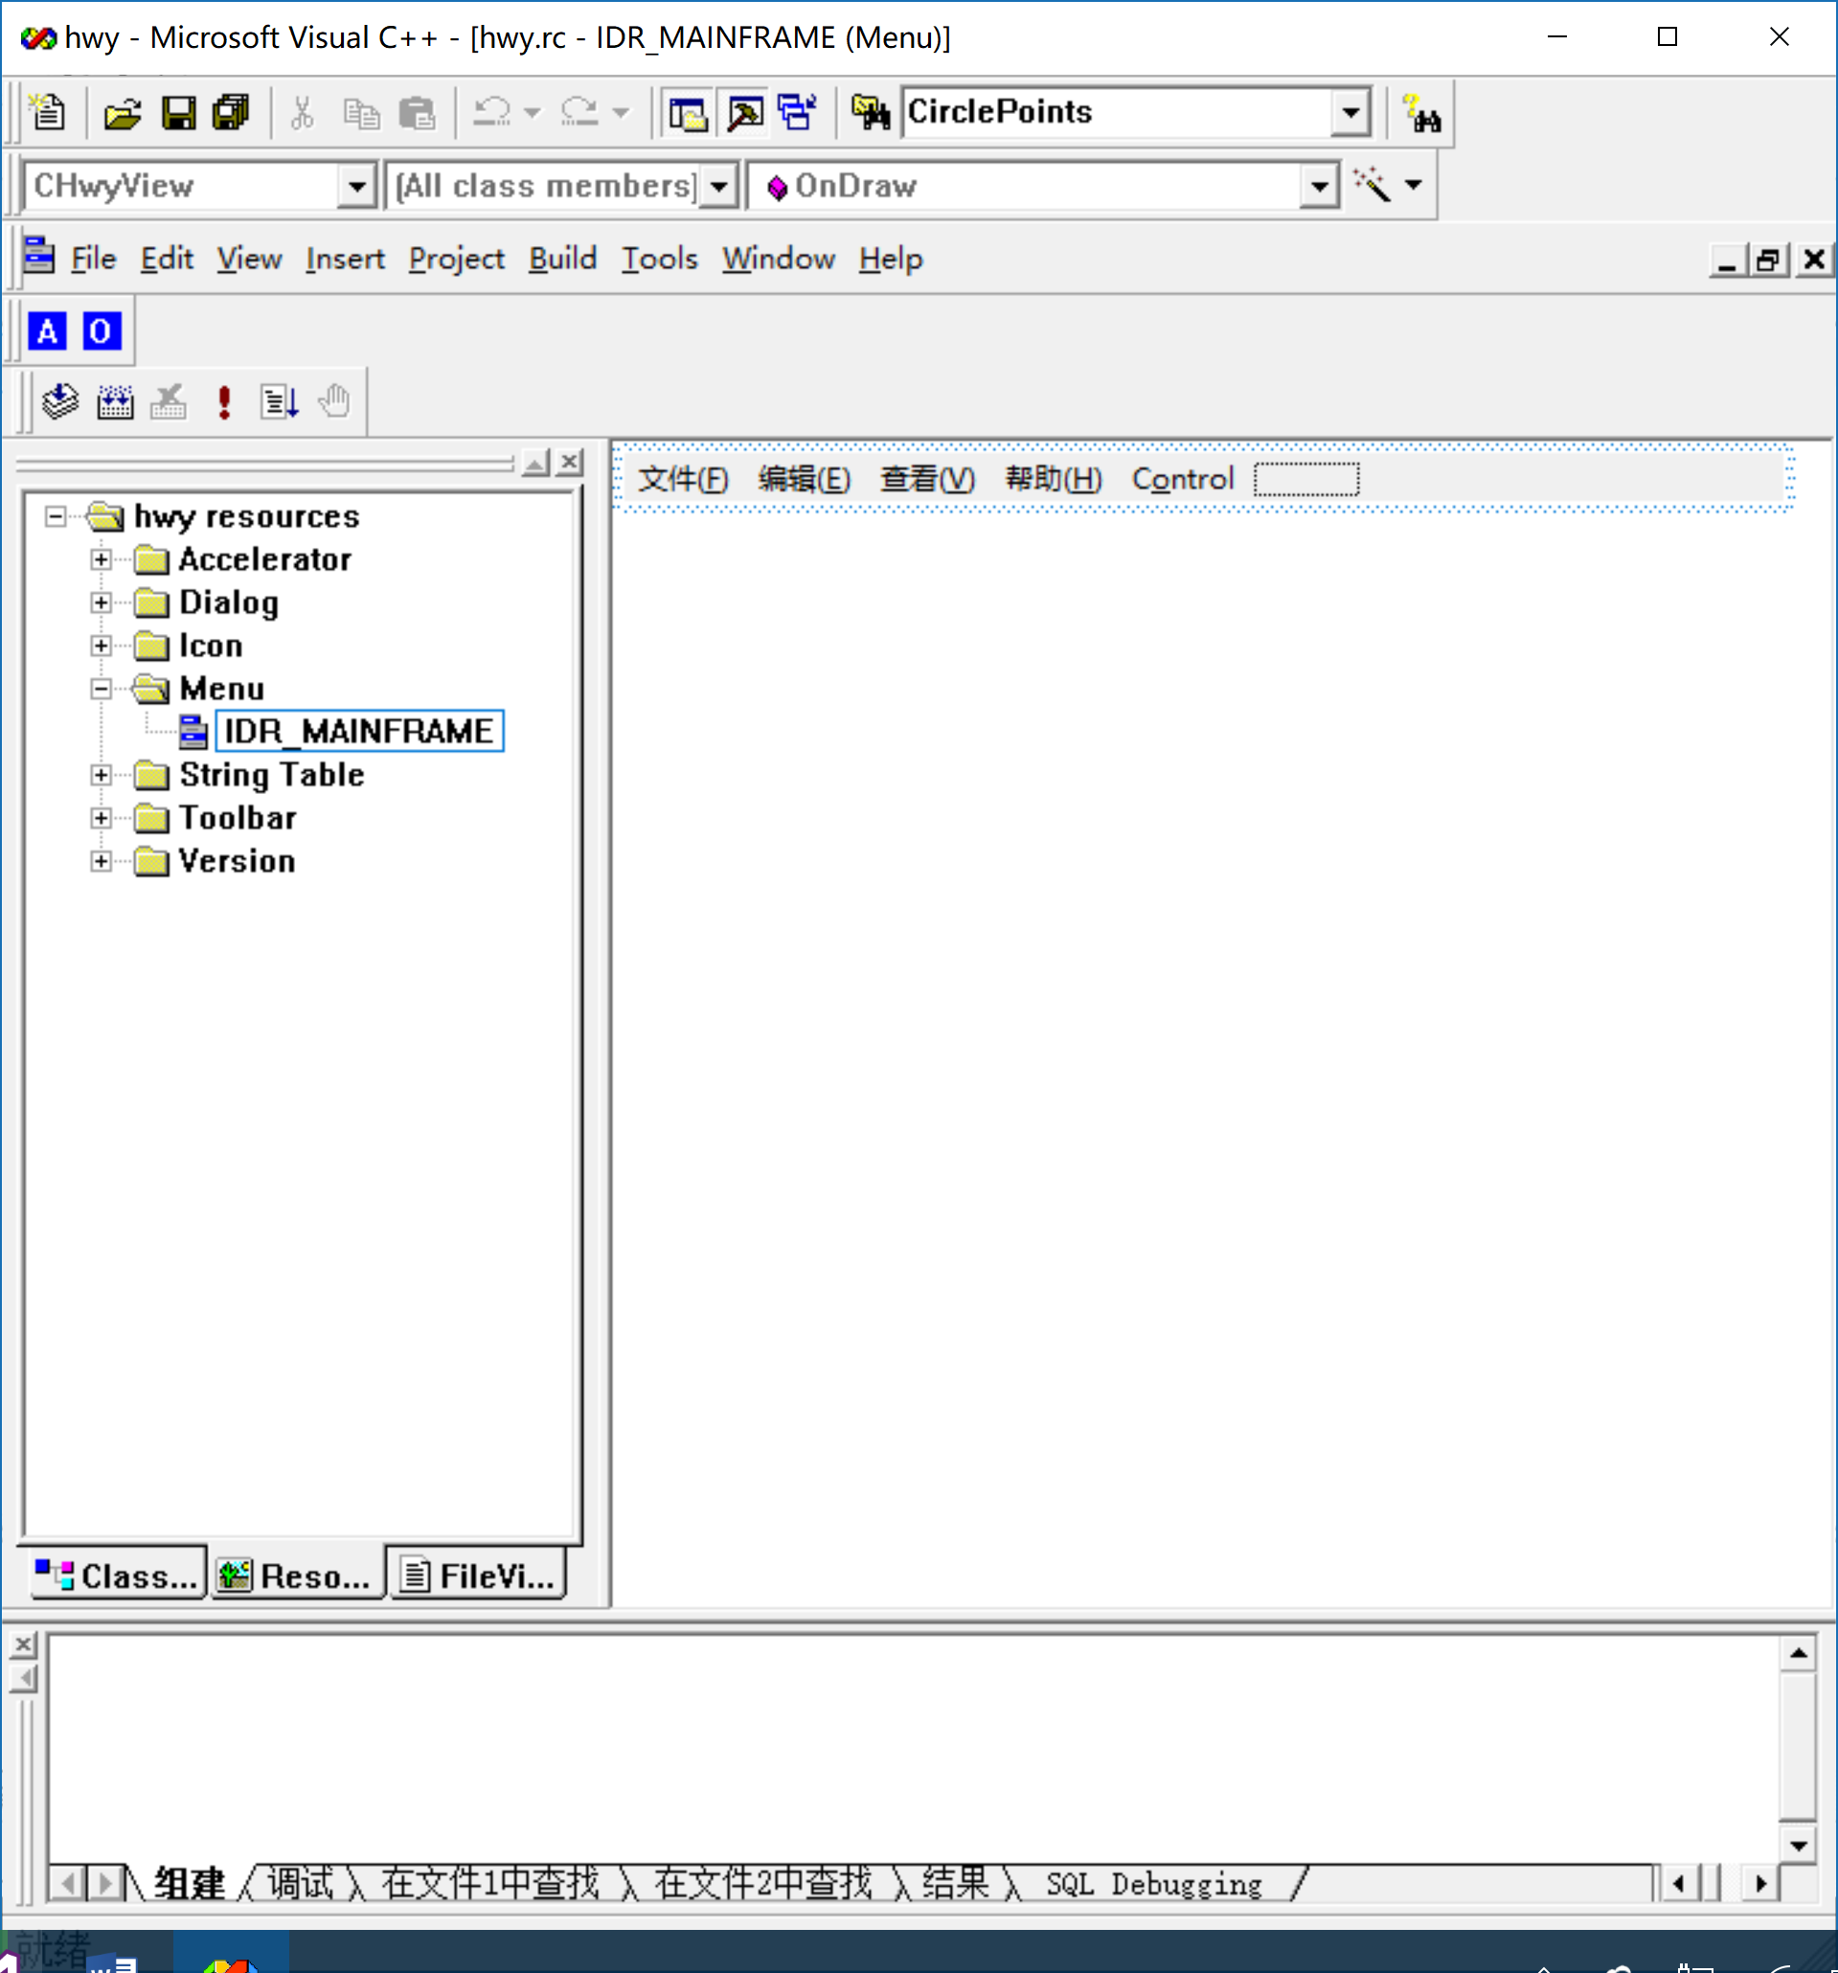
在顶端顶端画出Control按钮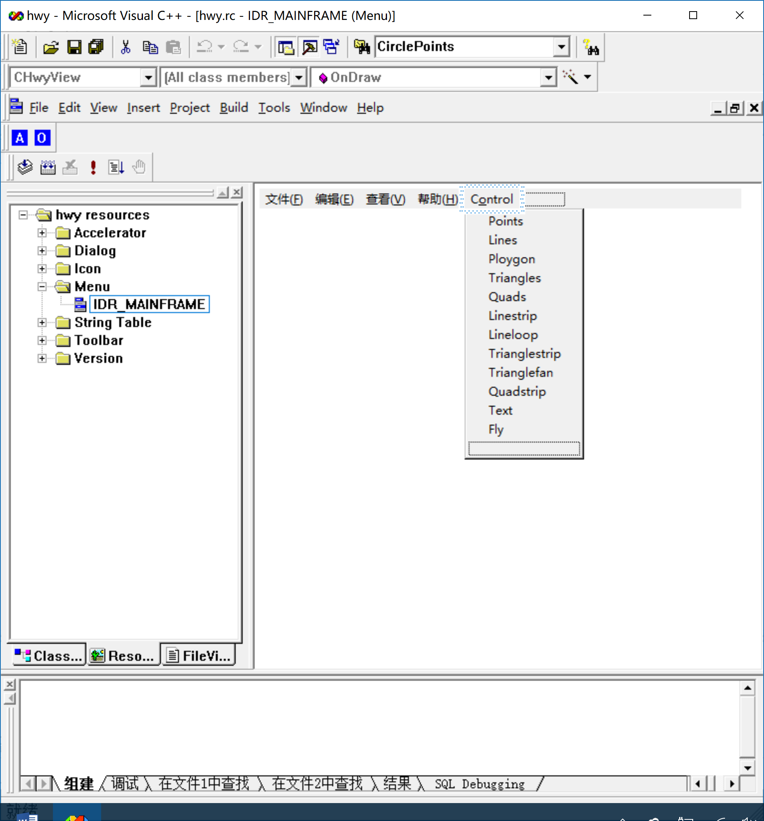
在Control的子菜单中画出应用各个函数的按钮：
具体做法是：
双击空白处，在弹出的窗口中填入相关信息
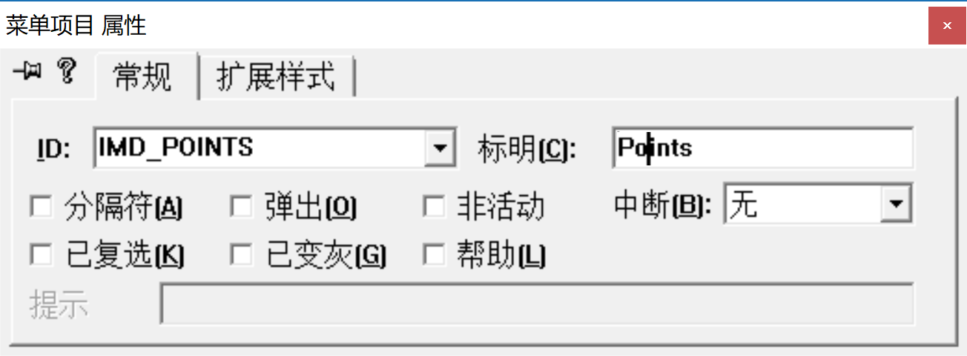
编辑各个按钮的功能使其起到更改控制变量的作用
在这之前我们定义控制变量m_controlHwy
int m_controlHwy;
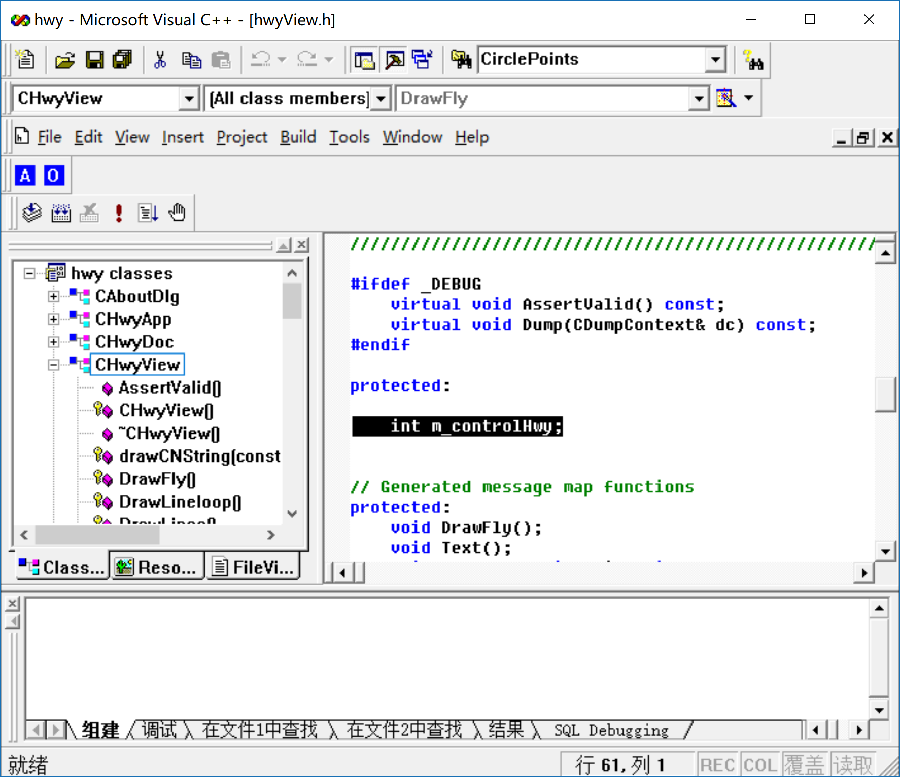
选中需要编辑的按钮(这里以Points为例)
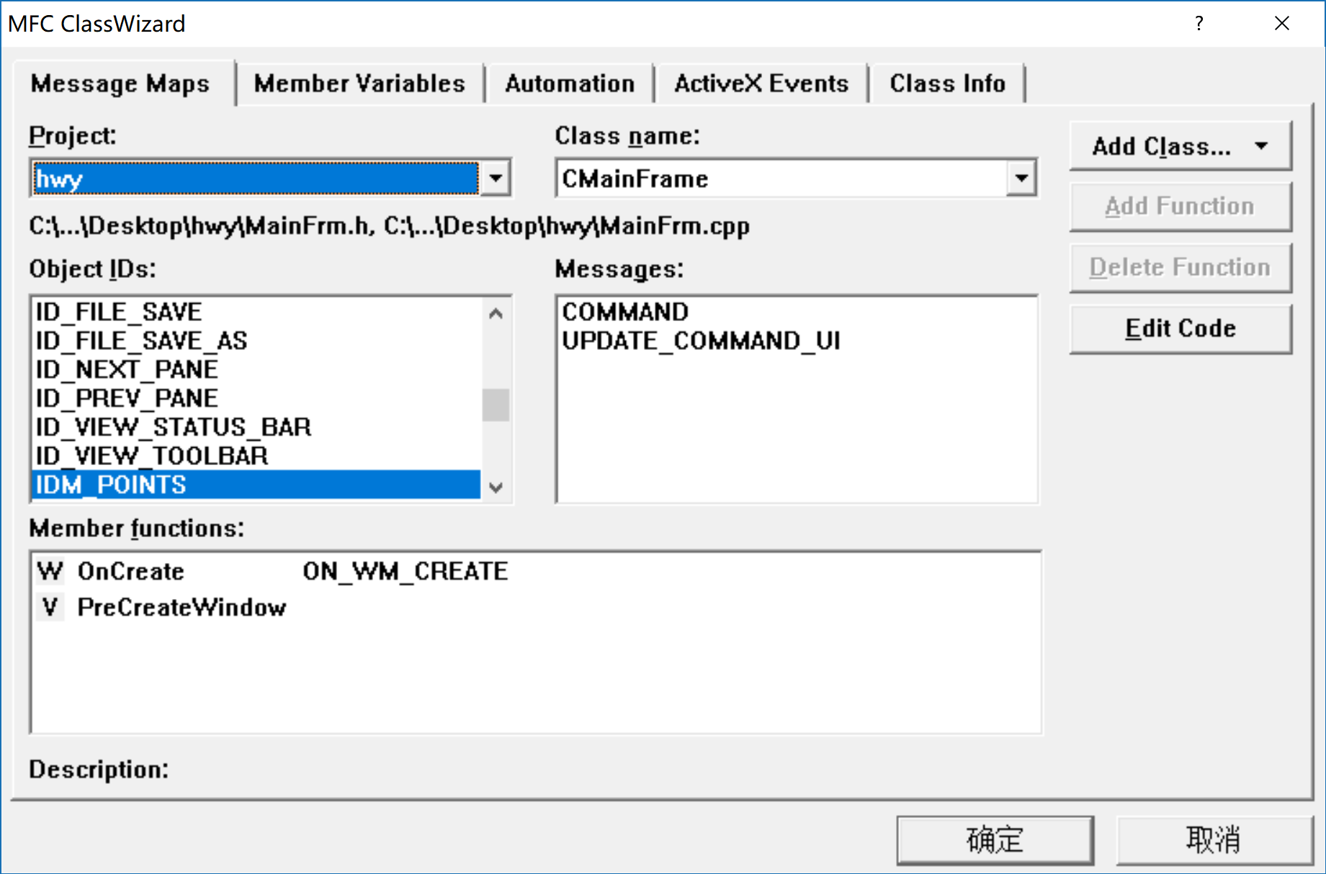
选择view类，选中Message栏中的COMMAND点击Edit Code
将控制变量赋值为Points；
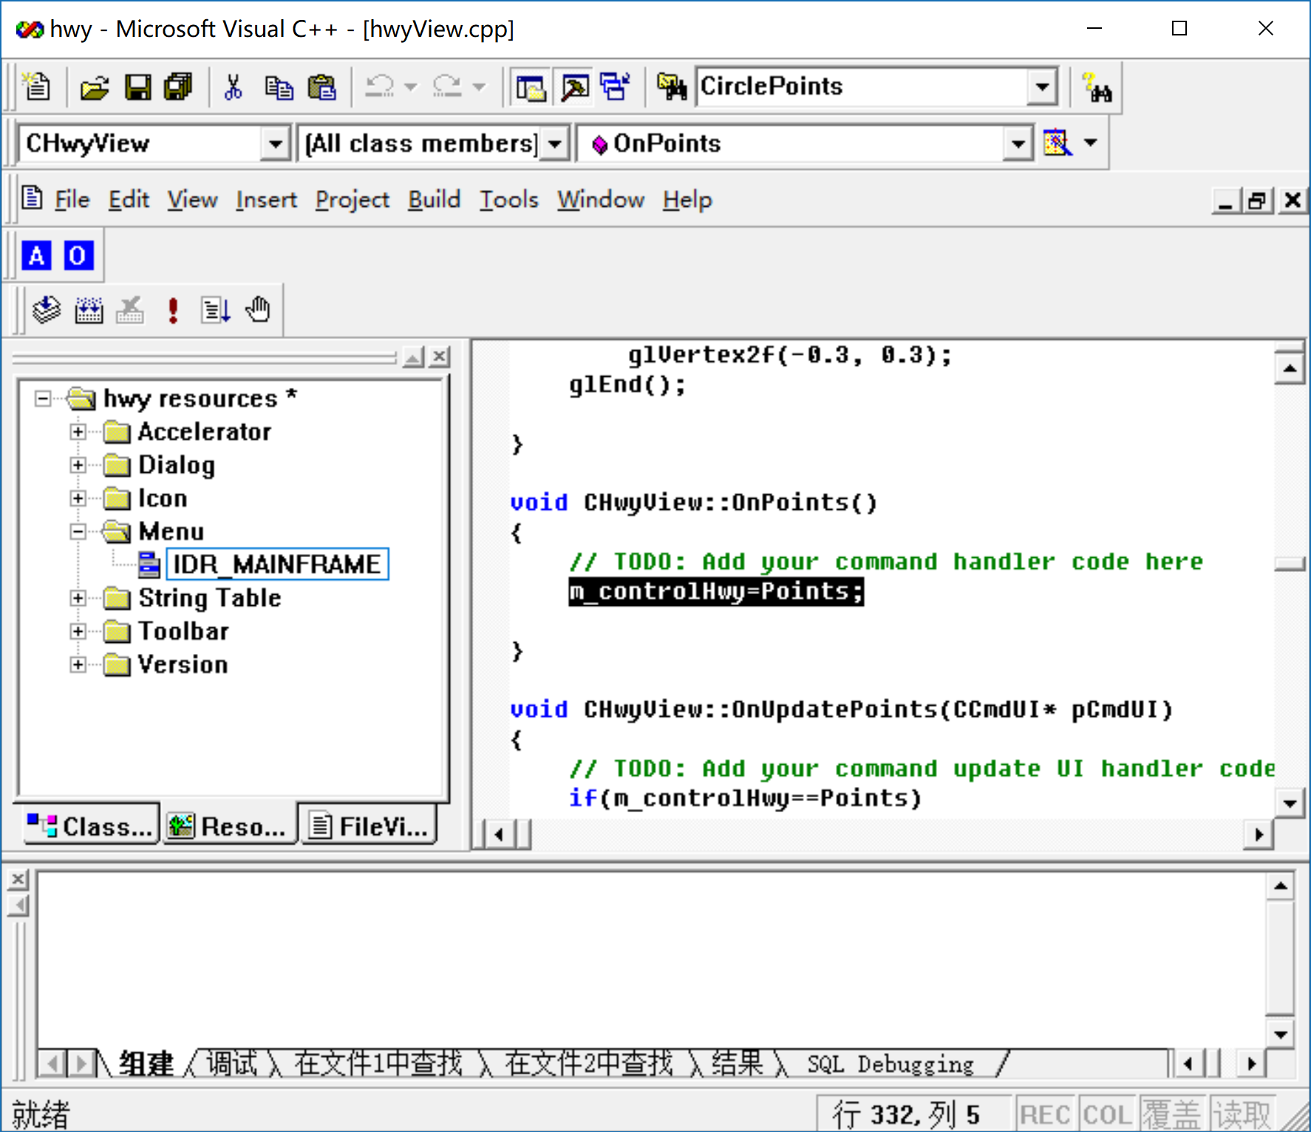
然后重新打开菜单选择UPDATE_COMMAND_UI
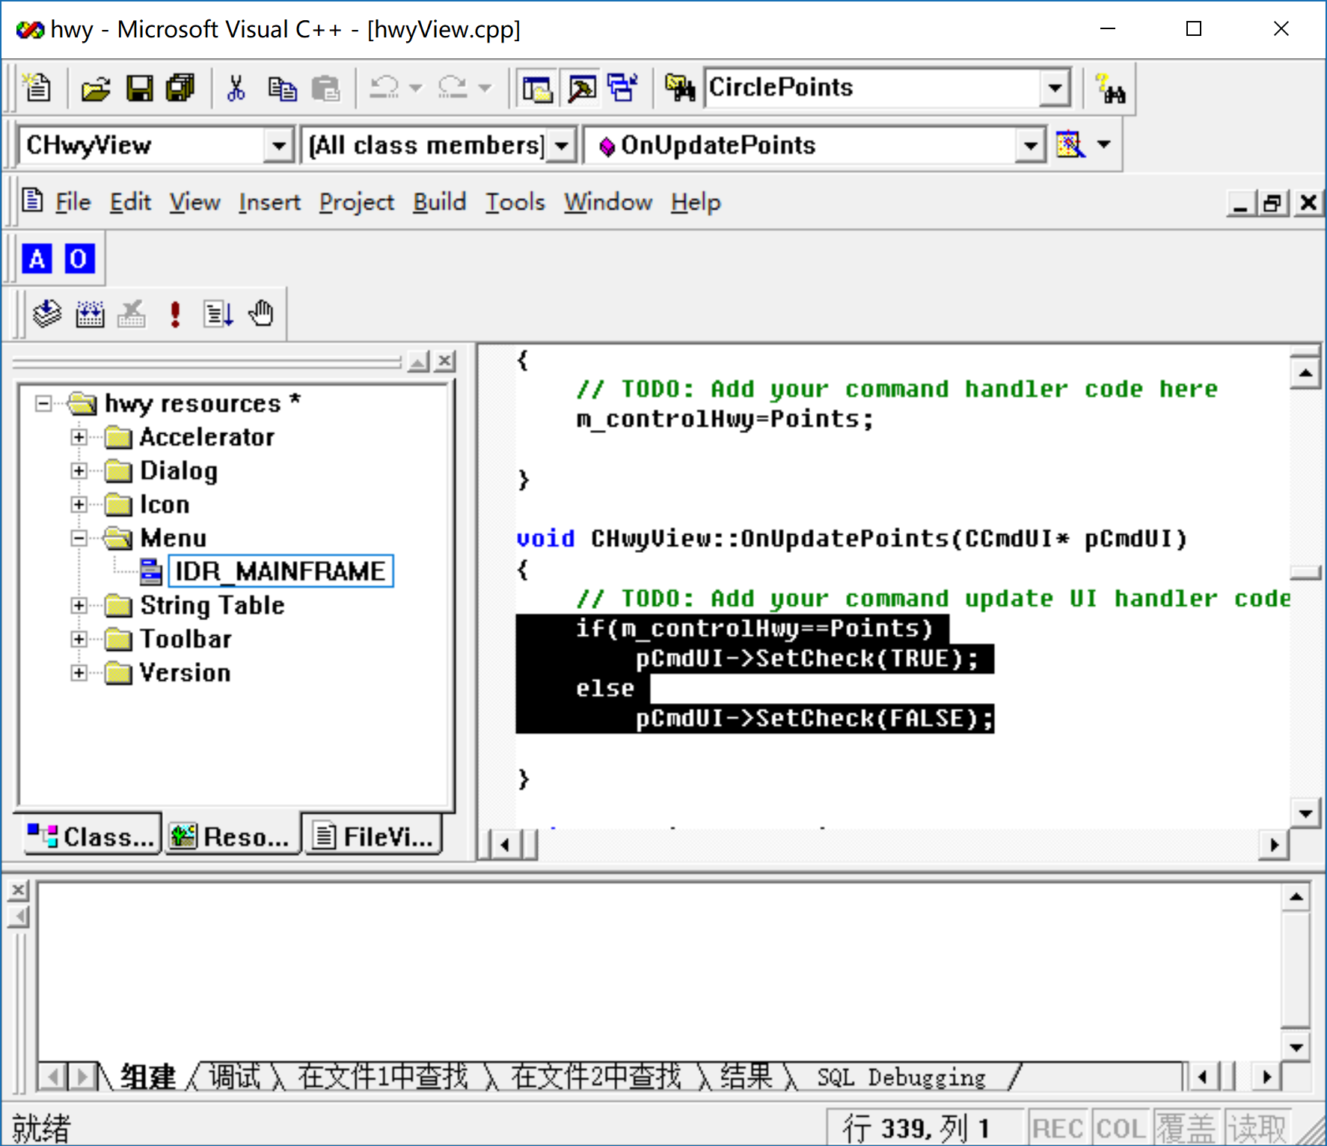
按照以上方法分别定义各个按钮的功能。
（3）最终效果：
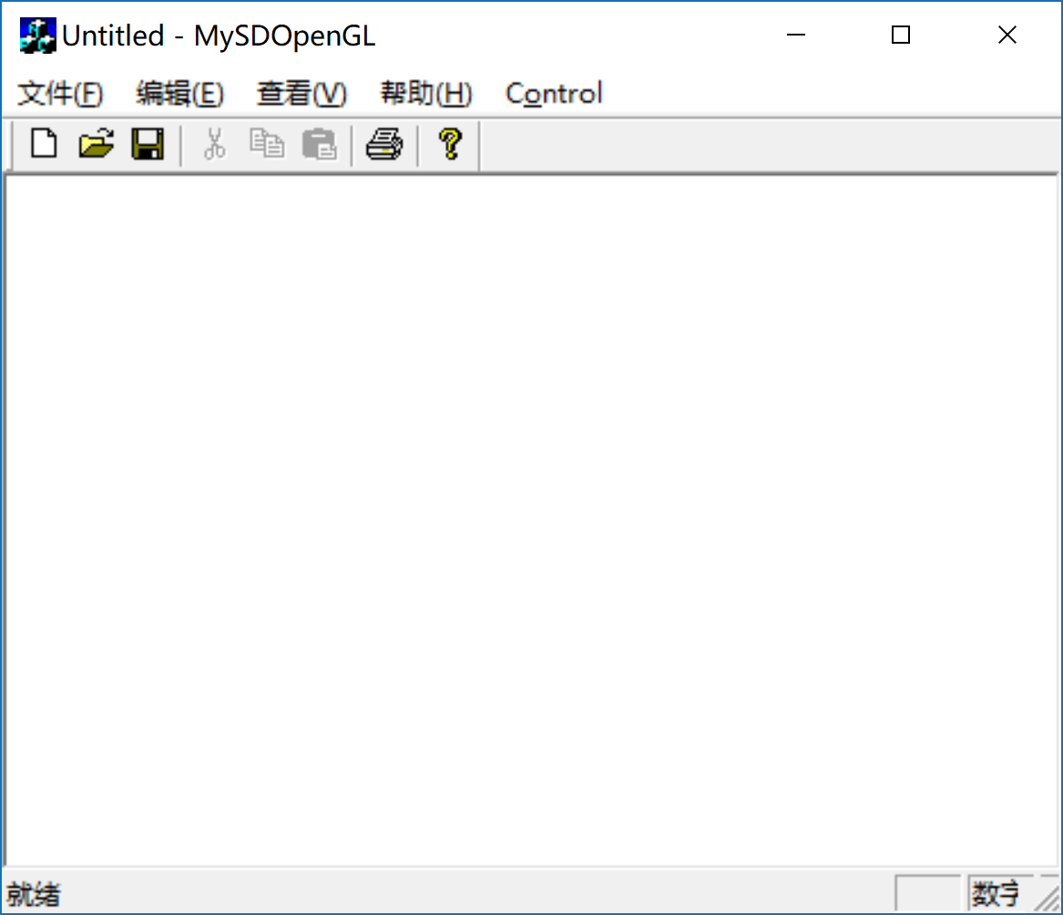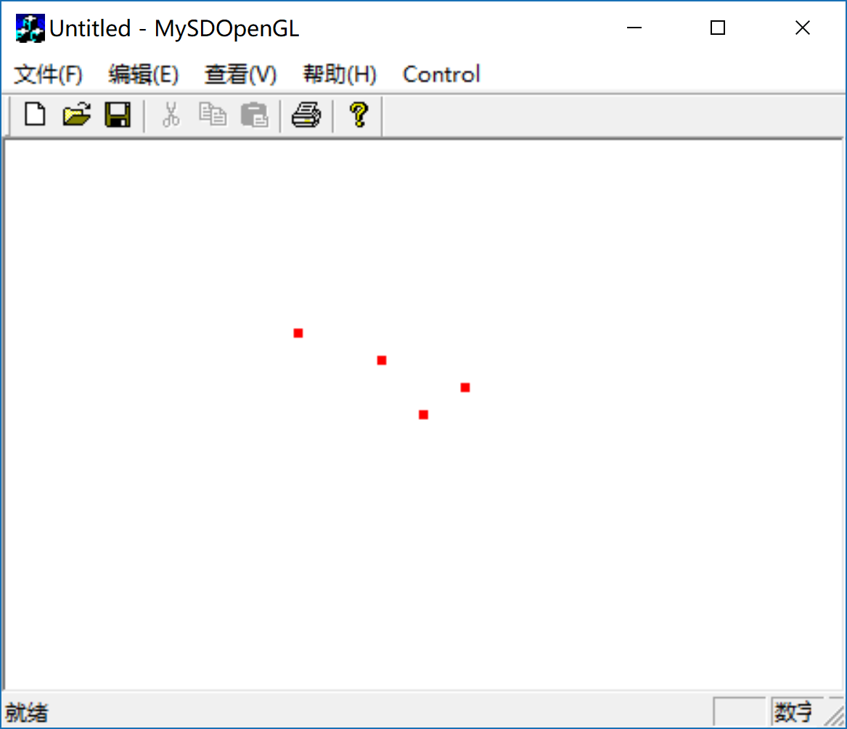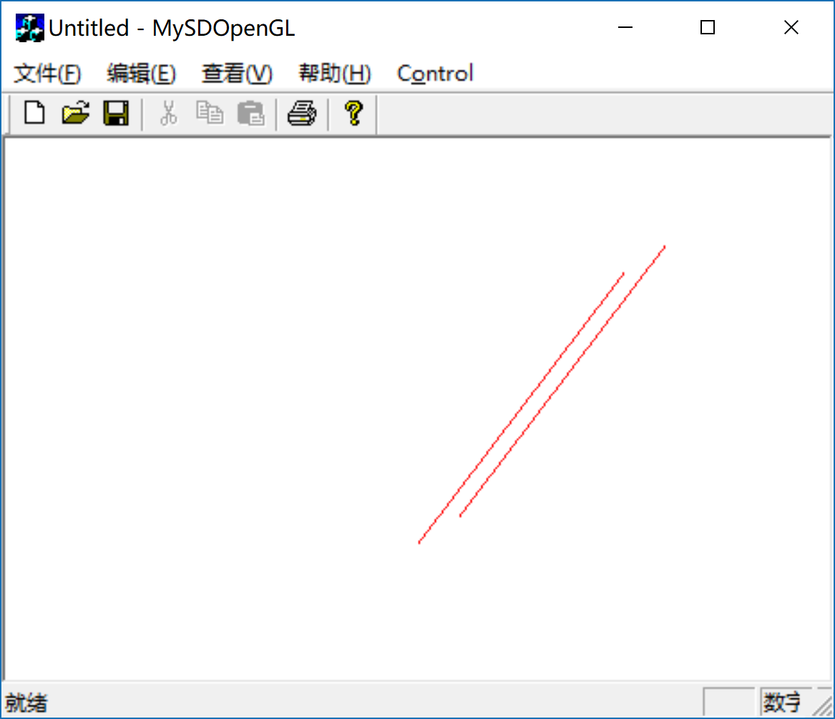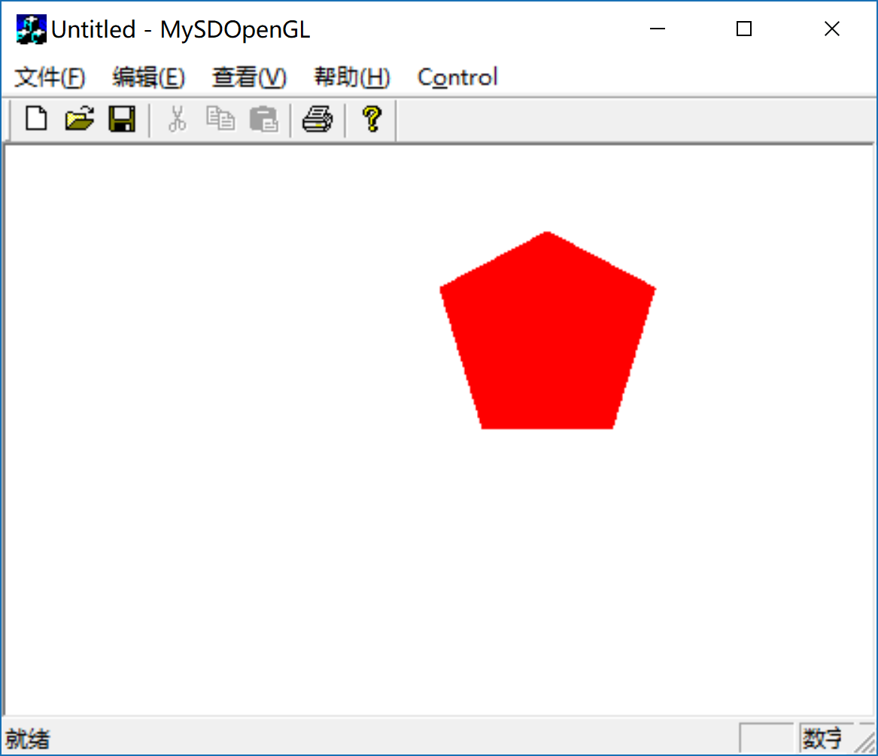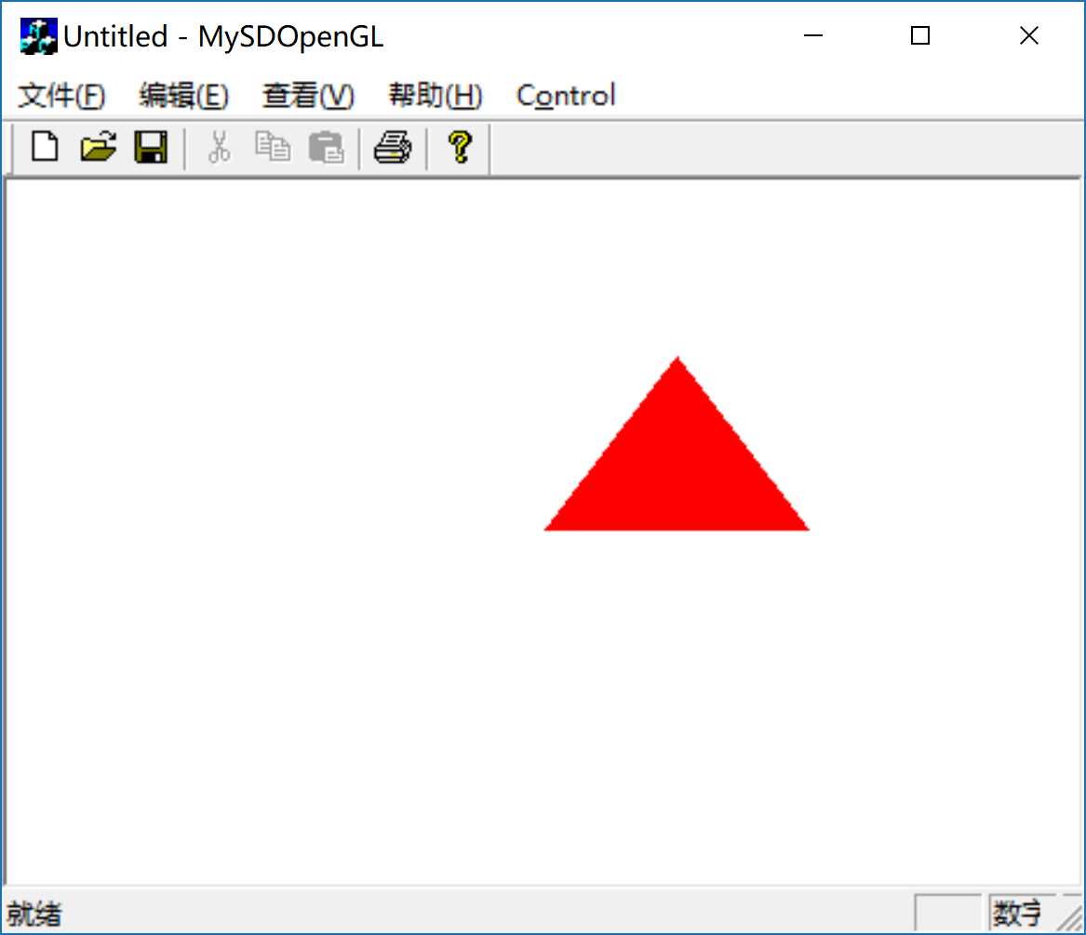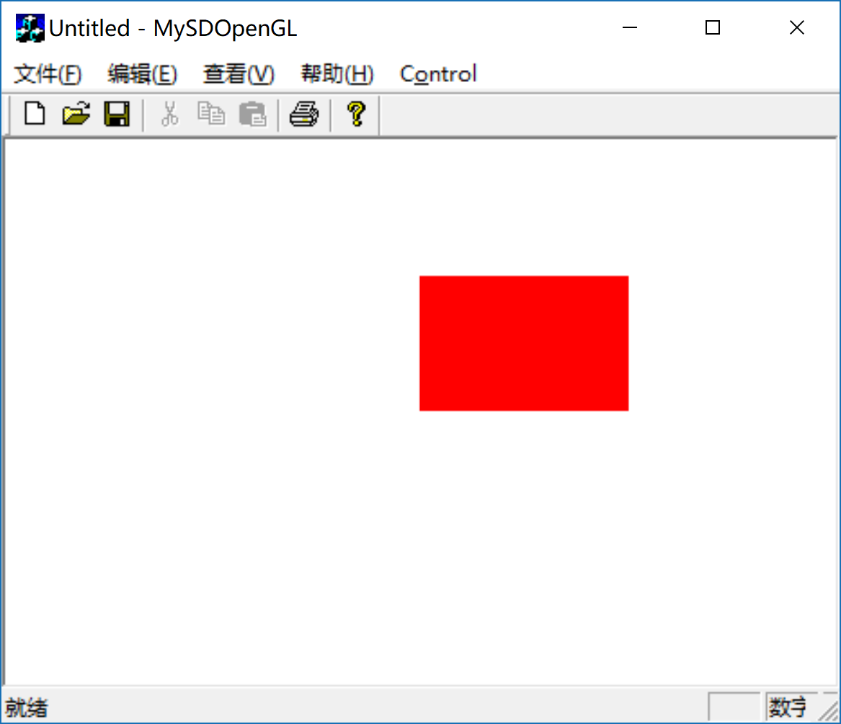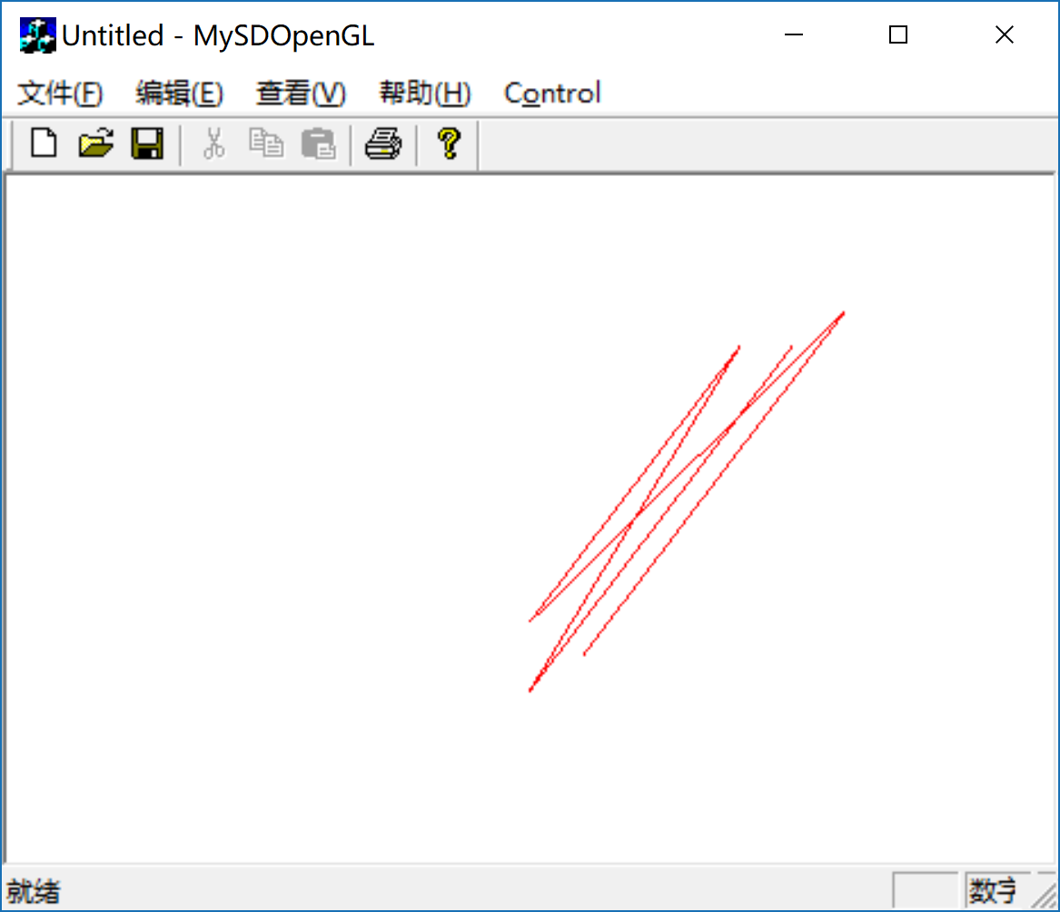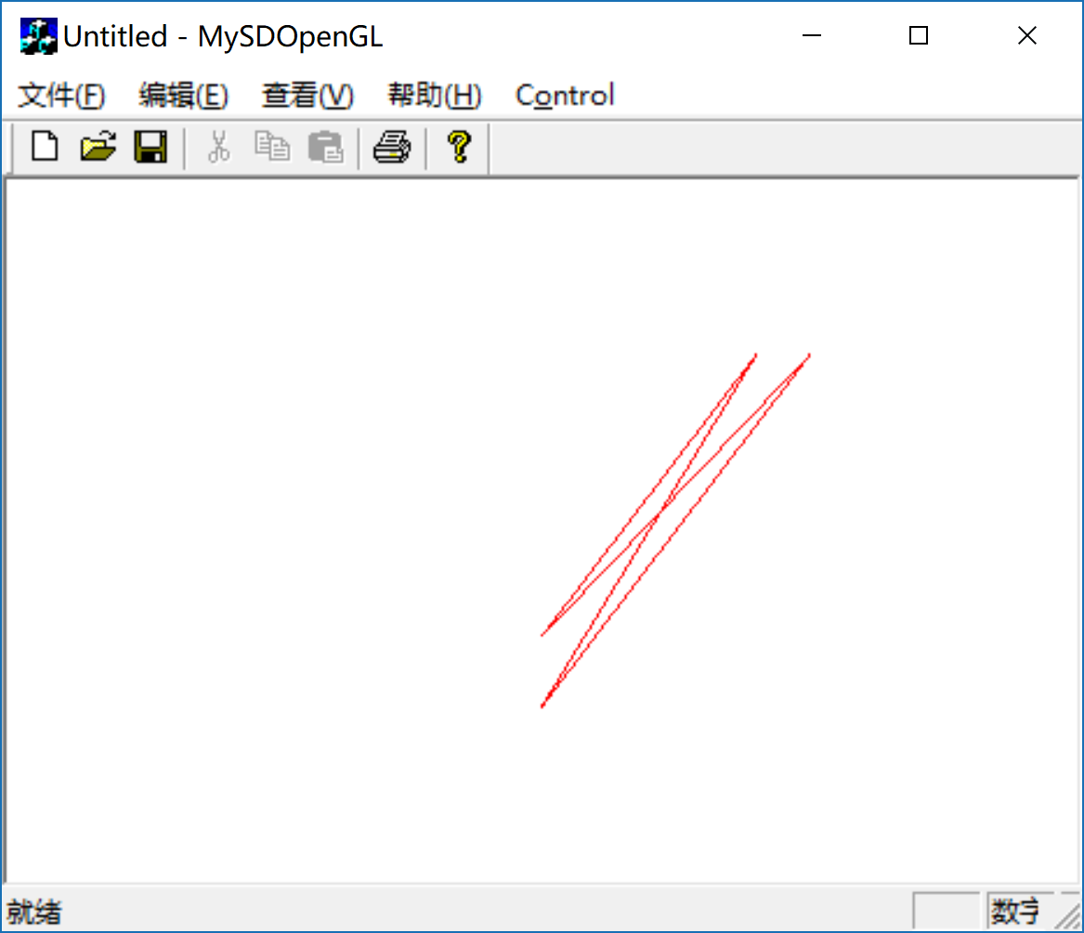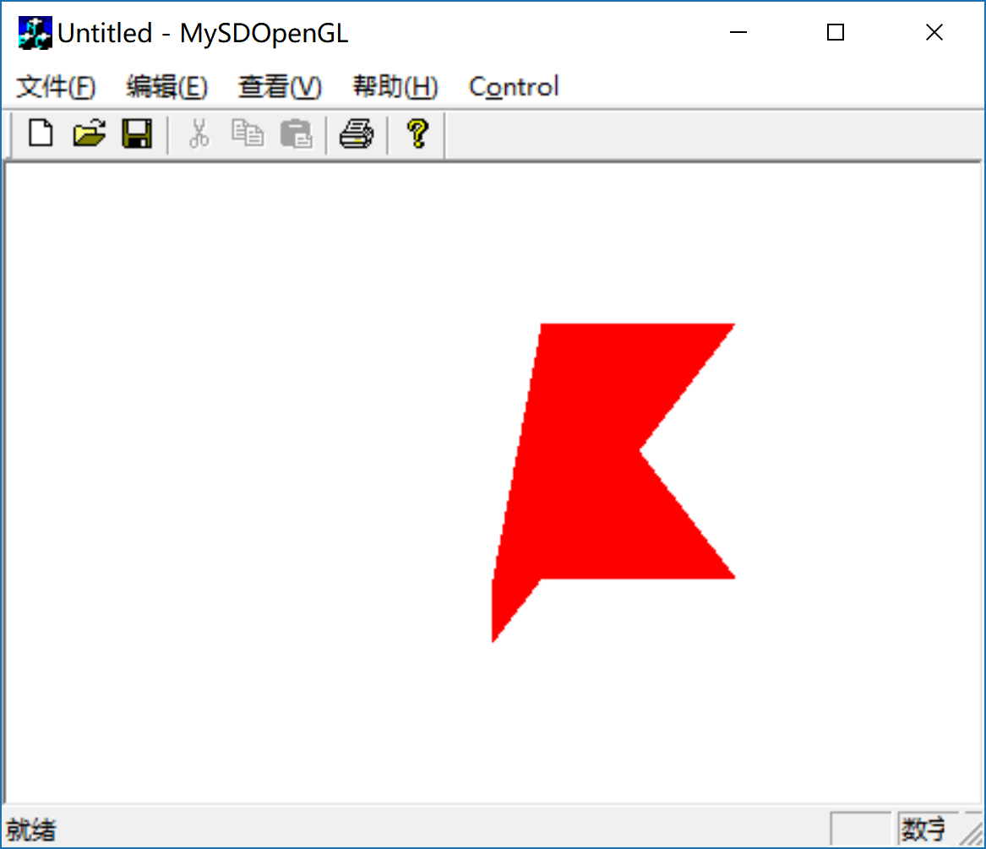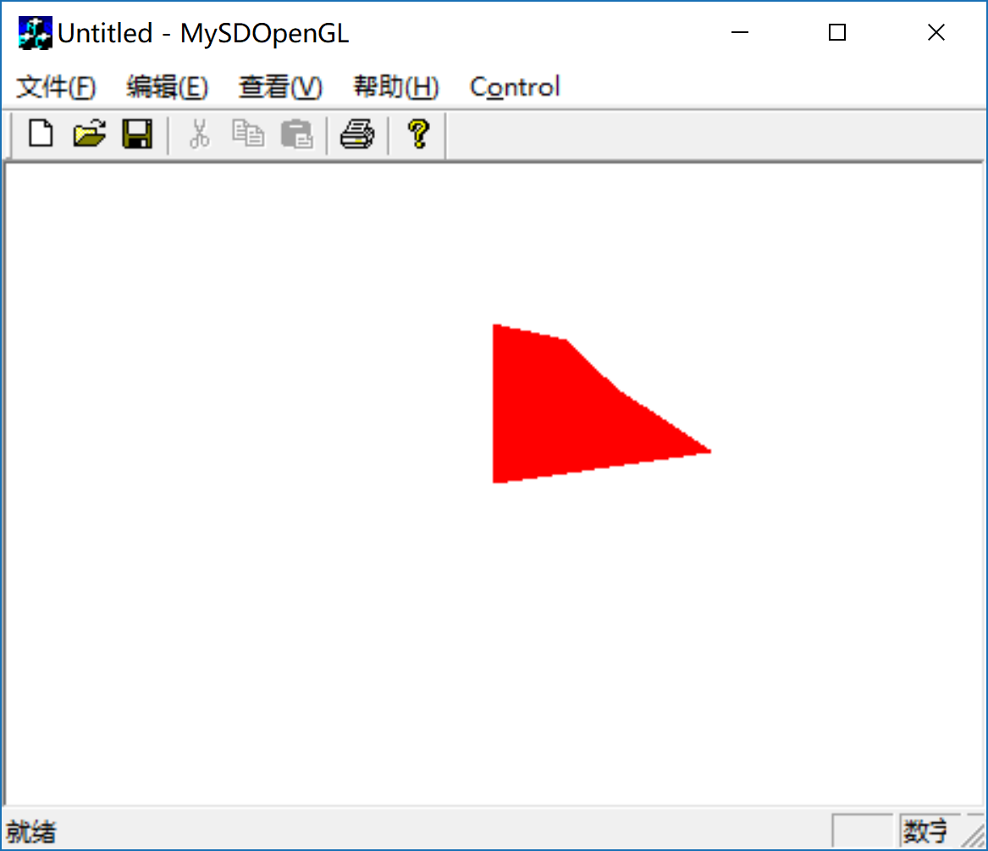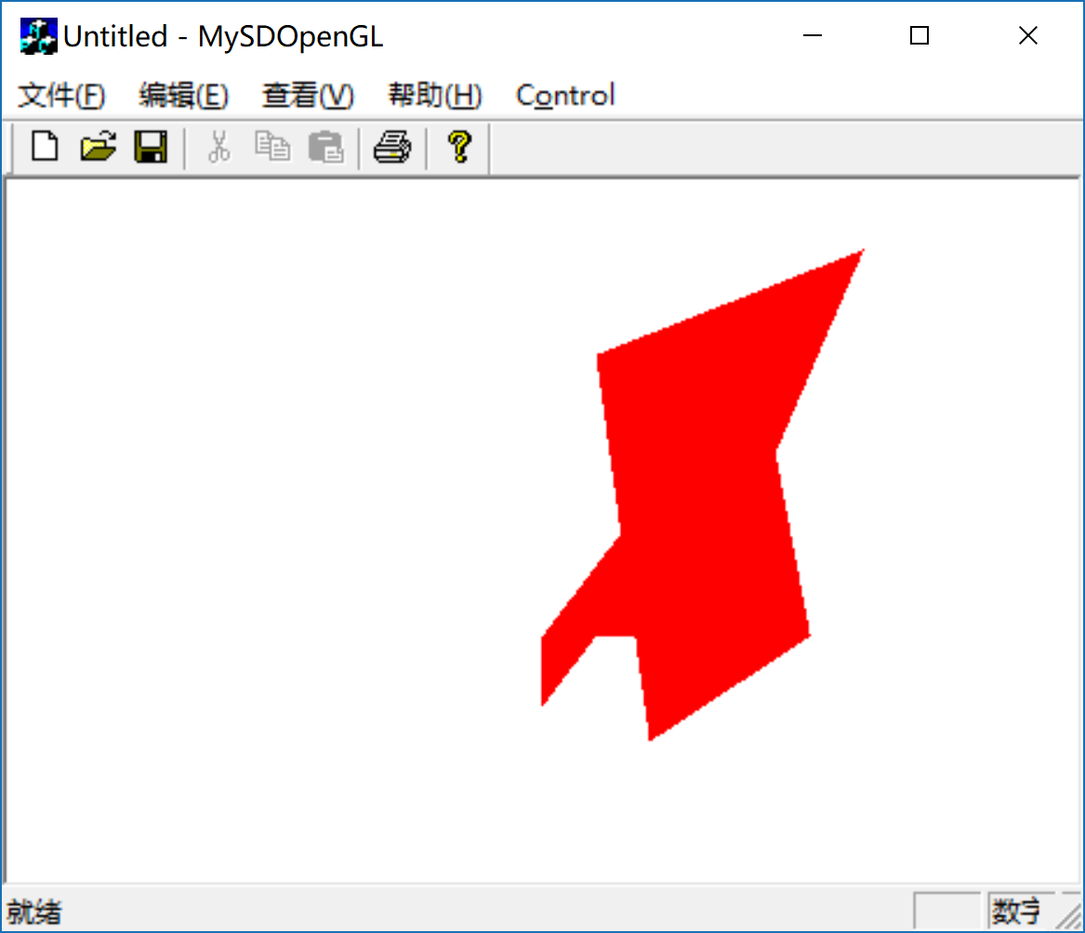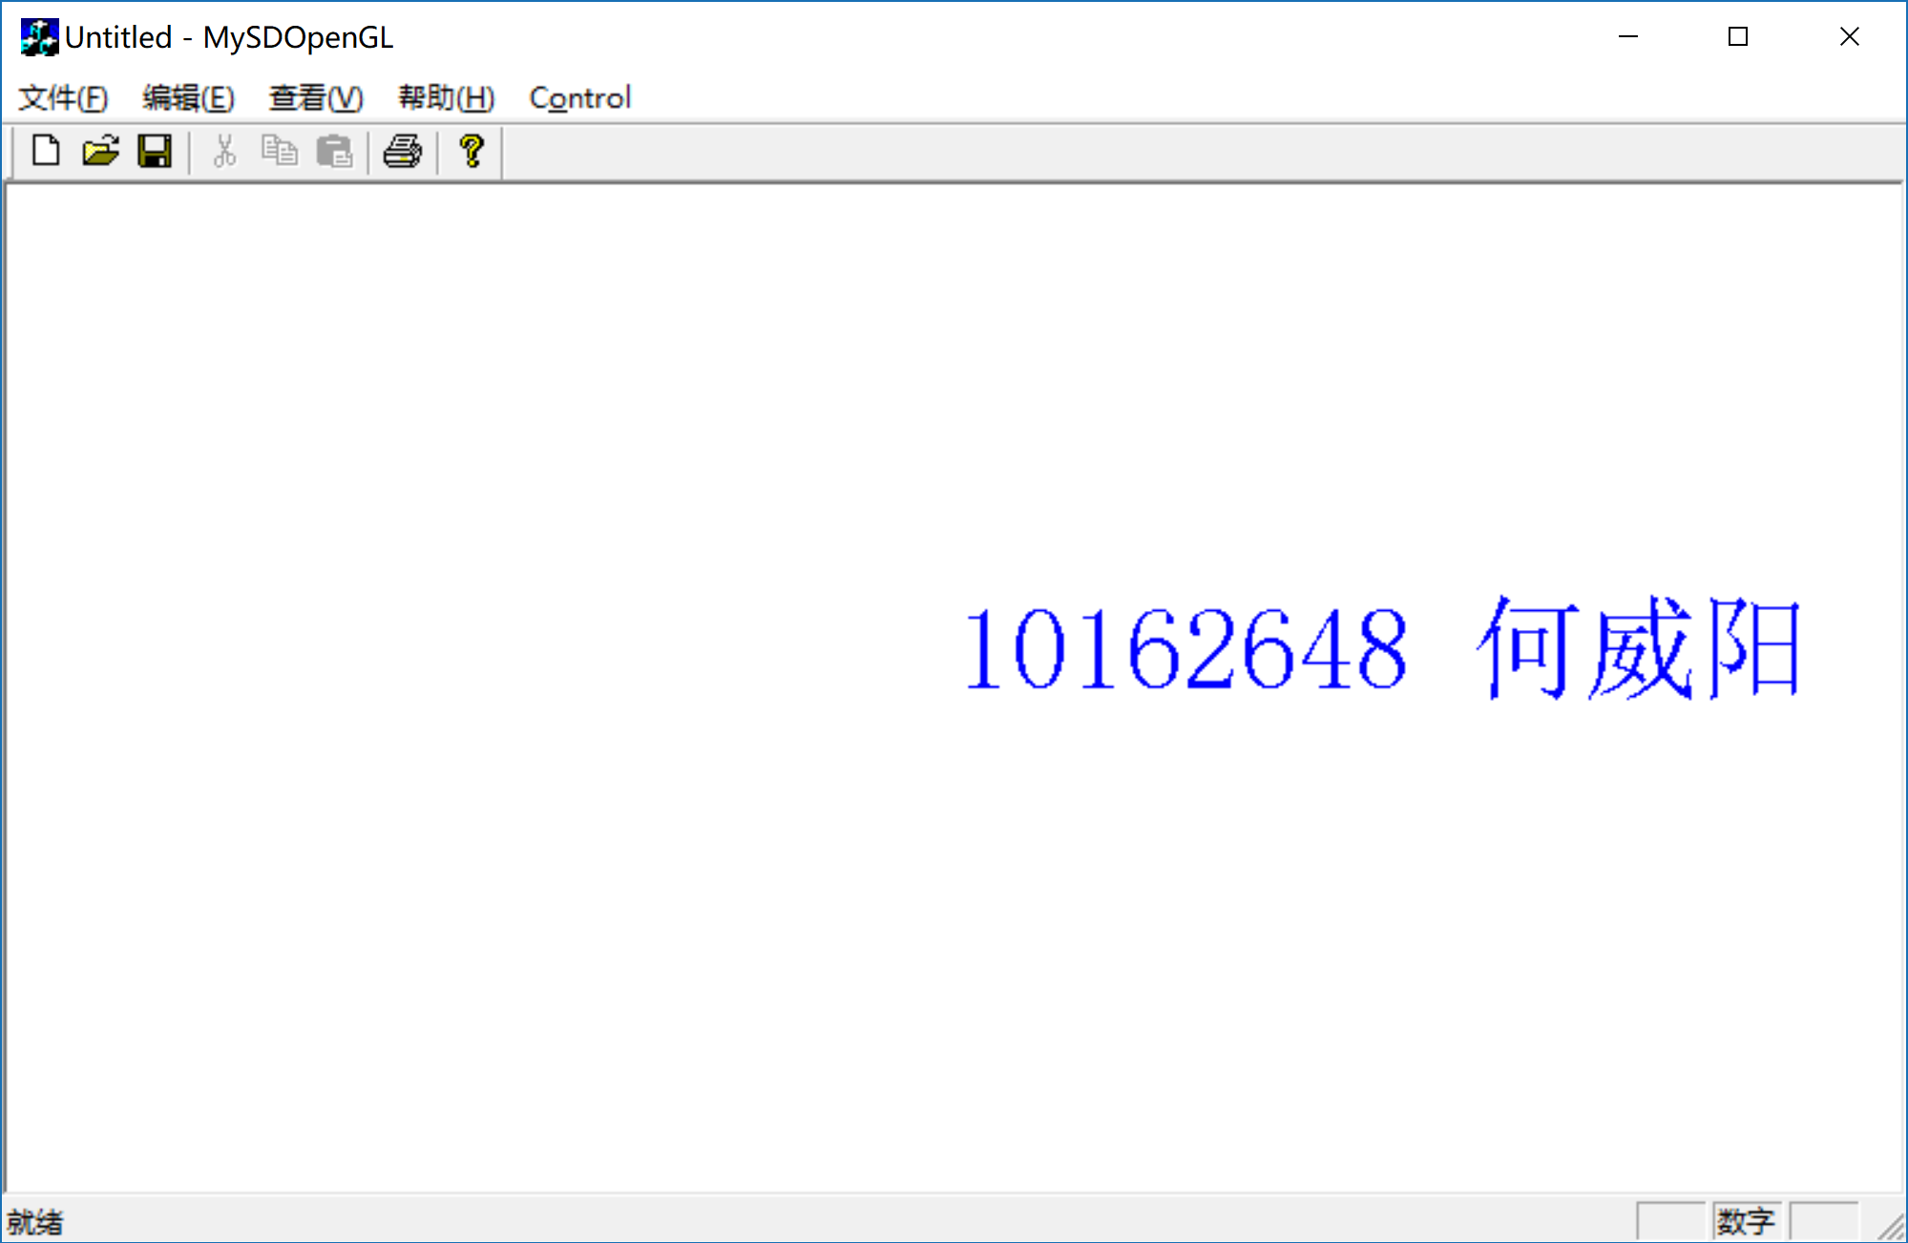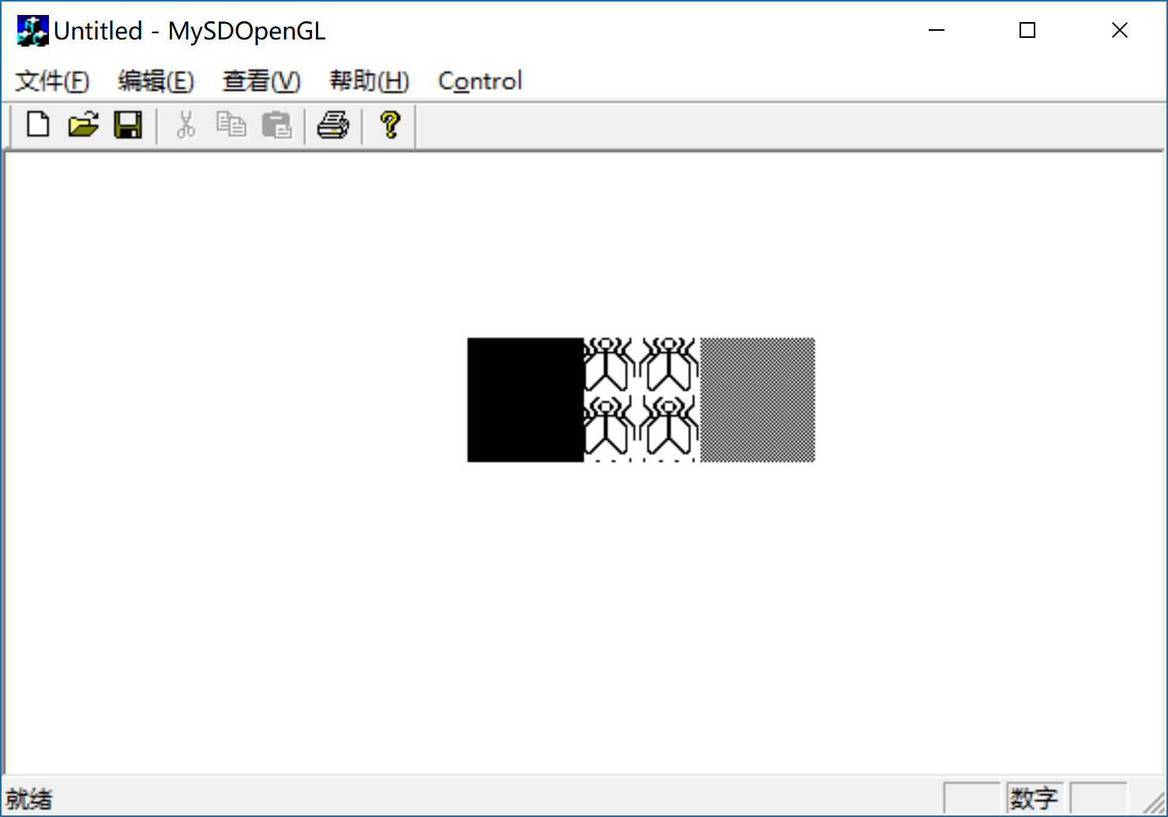

核心算法
见书本（P61-P62）表3-6各函数的应用；
见书本（P65-P66）；
见书本P71纹理映射字体的实现方法。

程序调试及运行结果的自我分析与自我评价
- 在定义控制变量的时候最好是有一定意义的字符否则在程序的编写过程中很容易混淆各变量的意义
- 在定义各按钮函数的时候注意类应该选择VIEW否则会导致程序报错
- 在绘制点画图形的时候要注意视点位置的选择，使得图片位于窗口内。此外，图的颜色要与背景色对比明显，否则图片生成后也不容易看见。

